#### **Daily Monitoring and Visualizing AWS cost usage using AWS Cost explorer**

**Important Note:** You need to make it a practice to continuously monitor the costs incurred on your account and avoid unnecessary costs by terminating the associated instances.You can also monitor your cost when your account is suspended.

Go to Nuvepro dashboard, Click on  **Cost Explorer**.

In case this tab is not available, Please raise a query with our Cloud Engineer.

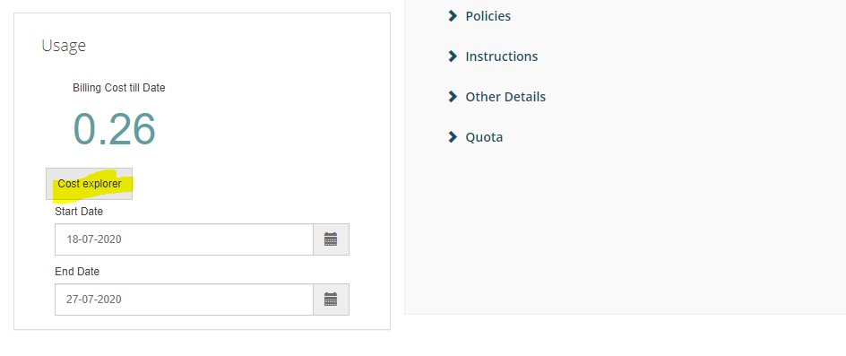

Now you will land on a similar page as shown below. Here, click on Explore cost

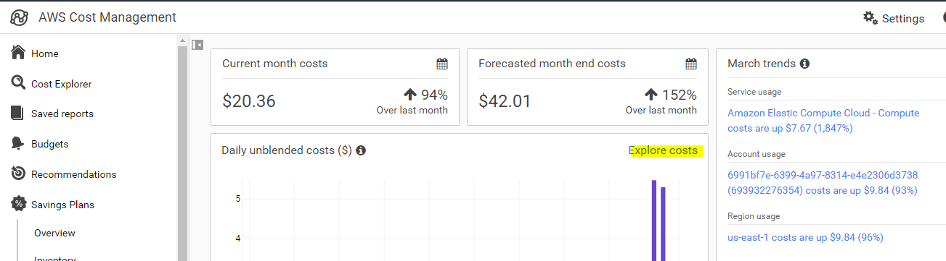

This will redirect you to a similar bar plot showing money spent each day. Now, click on Services to get the usage information service wise.

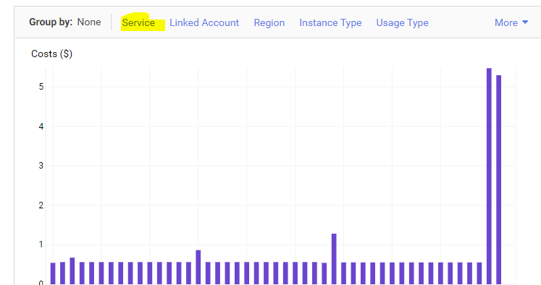

You will now see a similar bar part which segments the per day usage into different service categories.

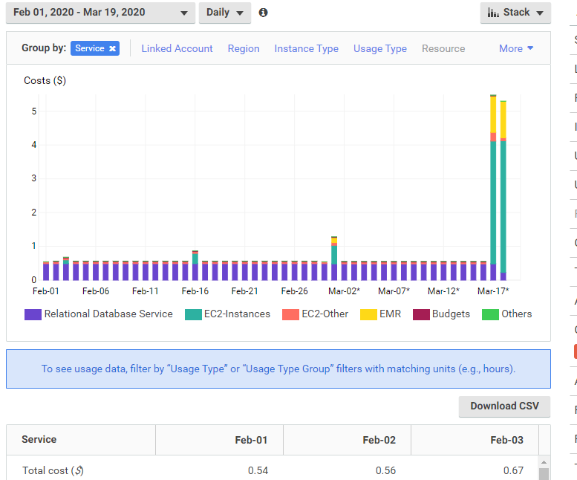

Apart from visualizing your usage based on service you can visualize based on Region, instance type, usage type, and so on.

Clicking on **usage type**, you will find per day cost incurred due to volume, data transfers, instance usage, and so on.

**Note**: You can also change the date [top right corner above the bar plot] to find usage statistics on a particular day.

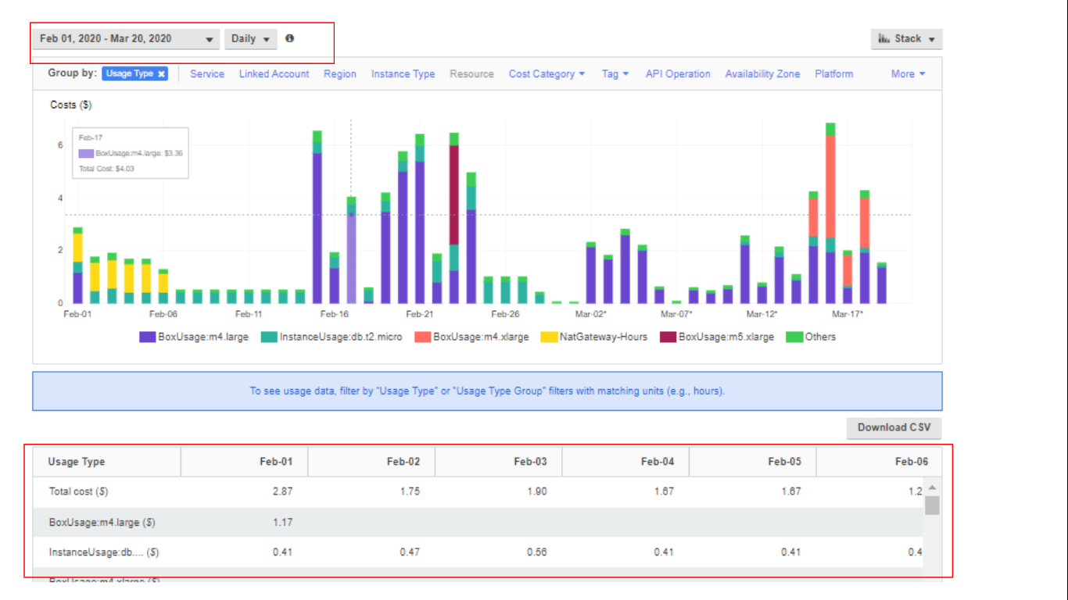

Monitor these AWS cost explorers on a daily basis and make sure you avoid any unnecessary charges happening to your account recursively.